The fundamental of the original game is a character on a 2d plane that is constantly in motion, by adjusting the direction of where it is facing it navigates through a maze. The objective of the game is to collect all the orbs laid out throughout the maze, whilst avoiding 3 ghosts that are released from the centre of the maze incrementally. The Pac-Man has 3 lives to collect to collect all the orbs. After being caught 3 times the user dies, and the game is over. Despite its age, Pacman remains popular today possibly due to its retro style and easily understandable rules. In this project I intend to build my own version of Pacman, retaining its core mechanics while introducing new features that increase replay ability and challenge. To achieve this, I will analyse the original game and similar maze-based games, whilst discussing with stake holders to create requirements for an improved game.

The demographic for my game is people of all ages. This is because research shows that all ages are represented when it comes to the people who play computer games, which is why I have chosen this demographic because the game is simple and intuitive for all ages.
Regarding the testing for my project, I will be using peers from the Sixth as a form of black box testing. This is so the program can be tested by someone externally who doesn’t know the inner workings of the software. This allows me to see what players experience while playing the game and how it can be improved to allow for a more engaging game.
My stakeholders will test the game from a consumer standpoint and will test the game from a perspective of how engaging the game is, how easy the game is to play and the creativity aspects. As well as this they will also give me feedback as to which part of the game, I should improve on to make the game more user friendly. An example of feedback given to me is to implement a ghost that could shoot pellets, to try and test themselves and their skill at the game. Another piece of feedback that was given to me was to create multiple varied game modes not just difficulty for the use to try and play, however I have decided not to implement this feature as I feel it would mean less time to be implemented, which may result in a product which has errors. This is why I am sticking with the basic 3 game modes easy medium and hard mode to be my primary game modes.
However, as a form of white box testing, I will be using peers and teachers from my Computer Science class to test my game from a game design and code efficiency standpoint. This will allow for an in-depth testing because it would allow for all the possible steps to be taken and tested, in contrast to the other stakeholders who would be testing for usability.
Some examples in the way they will be testing is if the game mechanics are fun and understandable as well as the velocity of the player and ghosts. However, my colleagues would be testing from a different standpoint; they will be testing for every movement option in the game to see if there are any results that are unexpected.

Research the problem: Similar problems to Pacman include games like Ms Pacman; this research focuses on grid-based movement, enemy avoidance and progressive difficulty, as these are considered core elements in my Pacman based game. Ms Pacman improved on Pacman by introducing multiple maze layouts and faster enemy movements. Alike Pacman the implementation of a physics engine or certain boundary parameters would allow for realistic collisions to take place. Furthermore, Ms Pacman's implementation of bonus items such as cherries would increase the retention from players. The first thing to do is compare the arcade game to their online versions and find out what makes the online versions of these games so successful. Arguably, the main reasons for the game’s success are the ease of the navigating and playing the game, which is due to the simplicity of the GUI (Graphical User Interface).
The game controls are intuitive such as using arrow keys to move as well as constant velocity of the Pacman being controlled. Ms Pacman is considered an improvement over the original Pacman due to the introduction of dynamic mazes where it uses 4 unique mazes with different colour schemes to retain user attention, preventing players from relying on memorised movement patterns. Another significant improvement over Pacman is the inclusion of bouncing bonus fruits: such as pretzels, pears, and bananas, which move through the maze and enter and exit through “warp tunnels” rather than appearing in fixed locations. This introduces a strategic concept of risk to reward as players must determine whether they can make it to the fruit, whilst avoiding the constant ghosts.
One significant addition is the inclusion of bouncing bonus fruits, such as pretzels, pears, and bananas, which move through the maze and enter and exit via warp tunnels rather than appearing in fixed locations. This introduces a risk-and-reward element to the gameplay, encouraging players to make strategic decisions while avoiding enemies. This feature allows players to improve their skills by seeing possible routes that could be made to the fruits.
Vibrant colours to make sure that people with colour blindness can still play the game without it interfering. This is to increase the accessibility of the game.
Clear section to show score and high score
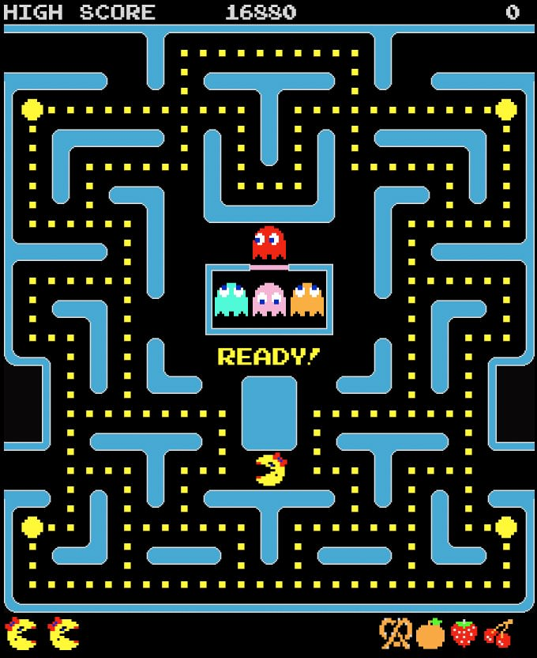
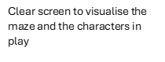
Clear panels to show collected fruit and lives remaining
Larger sized power orbs to visually show different orbs
An AI element in the game is the ghost’s pathfinding, to fins the most efficient route to the player using multiple algorithms for the different ghosts
Clear screen to visualise the maze and the characters in play

Another game analysed was Bomerman a grid based retro maze game. It’s known for its emphasis on spatial awareness, timing(bombs) and enemy ai’s. Players must navigate through a closed maze in a fast-paced environment using bombs to clear a path, in attempt to kill enemies. The online version also allows for multiplayer compatibility as the enemies can be real people instead of ai. The research on this game gave me the insight to add my own player abilities.
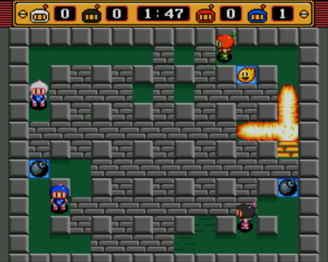
Clear bar to view time and points per player
The colour schemes of the board allow for an extreme contrast which allows for the players to see the game
clearly.

Bomb animations allow for retaining player attention

Powerup blocks allowing player to receive buffs

As well as researching these games I’ve also decided to have an interview with stakeholders to get their initial requirements for the game. This interview will be conducted to find the basic requirements from the stakeholders, which contributes to how the game will be created.
The main three headings are: what makes a good game, what types of visuals are wanted and what types of challenges or abilities are wanted. Based on these headings I’ve broken them down further with multiple different questions per heading so the requirements can be precise, and requirements linked to features of the game.

What makes a good game?
- What frustrates you with maze games?
- Should some sort of scoring system be implemented?
- How would you like to interact with the game?
What types of extra features are wanted
- What types of abilities would you want from the game?
- What types of challenges would you want from the game?
What game mode(s) would you want from the game
- Do two-player game modes make the game better or worse and why?
- What is your opinion on different levels of difficulty?
- If you could have a custom game mode, what would you include?

Interview with stakeholders about initial requirements:
What makes a good game?
What frustrates you with maze games?
Repeated levels, and no difficulty scaling, leading to boring repetitive gameplay
Should some sort of scoring system be implemented?
Yes, this is because it sets a goal for the players and tells you how well you’re doing in the game.
How would you like to interact with the game?
Using arrow keys and a special key for extra game mechanics for example f

What types of extra features are wanted?
What types of abilities would you want from the game?
Potential abilities for the game could be, an ability for the player to shoot projectiles at ghost, preventing points in the game where it is impossible to progress
What types of challenges would you want from the game?
Dynamic mazes less repetition and difficulty scaling, possibly ghosts that can shoot pellets as well
What types of visuals are wanted?
How would you want the menu system to be displayed to the users?
I would like it to be displayed in a way so the information that’s being displayed is concise so that it doesn’t take up the entire screen and so that theirs a keypress that can pause the game too.
How would you like the point system and lives displayed?
I would like it to be displayed so that its easily understood and eye catching for players
What game mode(s) would you want from the game?
Do two-player game modes make the game better or worse and why?
We’d think a two-player game mode would make the game better because it would allow you to play against your friend to see who’s better at the game.
What is your opinion on different levels of difficulty?
Different levels of difficulty would be entertaining as it would reduce the amount of repetitiveness that the game may struggle with
If you could have a custom game mode, what would you include?
I would have a game mode with rapid powerups, and faster ghost called extreme mode that would challenge the player
Requirements Table:
Table 1: Requirements for stakeholders
Stakeholder | Requirement | Description | Measurable data | Priority (High/Med/Low) | Justification
Alex (Child aged 14) | Req1 | Intuitive arrow key movement, easy layout | Collect first pellet within 30 seconds | High | Allows for easy understanding of game mechanics allowing users to focus on gameplay
Yusuf (Child aged 13) | Req2 | Interesting player abilities | Implementation of player being able to shoot pellets | High | Allows for greater game variety and dynamic gameplay
Jordan (sixth form student) | Req3 | Random maze generation | Achieve 90% unique layouts | High | Enhances replay ability which was the survey’s top request
Ahmed (sixth form student) | Req4 | Scaling ghost difficulty | Speed +20% after a certain objective is met | Med | Creates a challenging aspect to increase enjoyability
Mr. Read (Parent) | Req5 | Offline capabilities | Runs without network | High | Safety for young users from the internet
Ms. Patel (Parent) | Req6 | 2 player game modes | 2 sets of key binds with 2 active Pacman | Low | Creates a unique aspect from the base Pacman
Essential features of a computational solution explaining these choices:
The first stage of solving a problem is identifying if that problem can be solved using computational methods. It’s plausible to suggest a problem is computable when it can be solved using the below methods. There are some conditions when it comes to determining if a problem is computable, one of the main ones being if the problem can be solved within a finite and realistic time.

Computational Method | How it can be incorporated | Justification of use
Abstraction | This computational method can be implemented within my game, by getting rid of unnecessary details such as the colour schemes of the background. Furthermore, the maze can be treated as a collection of nodes and blocks numbering each wall block, orb, fruit, power orb. | Abstraction is the process of getting rid of unnecessary details of the problem. This is so I can focus on the  elements that need to be coded instead of worrying about unnecessary details.
Decomposition | Decomposition can be  implemented in my game by breaking down the large  problem of Pamanv2 into smaller manageable  problems. An example of decomposition is breaking down the game into smaller problems such as the User Interface and the game itself. | Decomposition is the  process of breaking down a large problem into multiple smaller problems. This  allows for the problems to be examined in higher detail.  The solutions to the smaller problems then act as the building blocks of the solution of the bigger  problem.
Thinking ahead | This can be incorporated in my game by designing the program in a way that allows updates to be made to the game in the future. | Thinking ahead is the process of coding your solution in a way that is  handled in the best possible way in terms of time to execute and the amount of  memory needed.
Algorithmic Thinking | Algorithmic thinking can be implemented into my game by designing a step-by-step plan, implementing that plan and testing that plan. After this any changes can be made. | Algorithmic thinking is a way of working out a solution through the clear definition of the steps needed.
Performance modelling | Performance modelling can be used in my project by  measuring the response time | Performance modelling can be used to understand how  the program will behave

Performance modelling(continued) | taken, to measure any.  issues, which can be used to address performance issues. | under different load conditions and constraints.
Pipelining and thinking concurrently | This can be used in me  project because my game runs at a constant frame rate, which means the  program can’t wait for an instruction to be executed.  Thinking concurrently can be implemented because it  would allow for prototypes of my game to be implemented, because multiple different things are being worked on at  the same time. | Pipelining is a technique used by the CPU, which allows it to execute multiple  instructions simultaneously.  Thinking concurrently is the process of working on multiple problems at the same time.
reusability | This can be implemented into my project because there are a lot of reusable elements in my game, such as buttons and ghosts ai which allows relevant modules and classes to be made. | This technique refers to the degree to which a method, or software component can be used again in a new application with minimal or no modification.

Limitations of the proposed solution
One of the main limitations of the proposed solution is that this games’ audience is for people playing on computer, which means that people who play games on their phones or tablets won’t be able to access the game. This is due to PyGame, the module used to build the program, is not mobile friendly.
A lot of many modern videogames have a tutorial about their game or a “tutorial”, which could be useful for new players because it allows them to get used to the controls and the constraints of the game. I would like to include this in my game, but due to the time constraints I don’t think I will be able to. However a way it can be implemented is by adding a screen, which can be accessed through the main menu, which explains the rules of the game to the player, if they don’t have experience playing the game. Advanced players might find ways to trick the A* algorithmic ghosts. Moreover, the proposed maze generation may only be semi-procedural which conducts controlled randomness for fairness, which means we don’t achieve full randomness.
Furthermore, there are technical limitations where, there may be noticeable performance constraints on low end hardware, for example PyGame at 60fps on 2ghz CPU handles 30x30 mazes but larger 50x50 drops to 45fps without optimization. This would make it hard to play on older PCs. Furthermore, with the proposed solution we are assuming that all players are comfortable with solely arrow keys when some demographics would rather play with WASD, touch screen or mouse movements.

Specify the proposed solution
Software and hardware requirements
I will be using Python as my programming language and PyGame as my game engine.  Python: 3.8+ and pip for libs such as NumPy 1.21+ | My reasoning for using PyGame is that it allows for event handling and display to be easily implemented into my game  The use of libraries such as NumPy was to calculate collisions between the ghosts, walls and the player(s). Handling vector data for the grid-based movement  Another reason I’ve chosen PyGame is that it’s a library that can be used on windows, macOS or Linux.
I will be using the Windows operating system | This is because Microsoft’s Windows is the most used operating system in the world  accounting for 67% share of the desktop, tablet and console OS in August 2024, which allows my game to be played by a majority of  the target audience (15).
Software requirements
Development of the program will be conducted through vs code with python extension and Git for version control | Supports an efficient and structured programming environment which features syntax highlighting, debugging and error detection.  Git was used to prevent loss of work and work in iterations to previous developments

Operating System: 64-bit Windows 7 or later or OS X 10.11 or later | This is so it can make efficient use of the CPU. A reason for this is that a lot of processes are being run in the game and the processor needs to be powerful enough to manage them simultaneously.
Processor requirement: 1.5GHz or faster | This is because PyGame uses software rendering, which means it relies on the CPU to draw the graphics making it less efficient for complex scenes; however, this is irrelevant in my game as there won’t be many “Complex scenes”.
Minimum RAM: 2GB  Recommended RAM: 8GB | This is the lowest memory required to have an interpreter open without many lag spikes. The recommended RAM allows for the user to manage large datasets and run multiple  applications simultaneously without any lag.
Minimum storage: Python 10GB Minimum storage: VS code 200MB  Recommended storage: 100GB | These are both the minimum storages needed to program using either of these editors.  The SSD accelerates the work, allowing for faster access the files and processing, which is necessary when working with large amounts of data.
Monitor | This is so the game can be displayed to the player.
Keyboard | This is so the player can interact with the game as well as the GUI (Graphical User  Interface).
speakers | To listen to game audio, including sound effects and music
Hardware Requirements
All the hardware requirements were found on geeksforgeeks.org (3).

Success Criteria:
The following points are the success criteria for my game, which are split up into essential and desirable. This is because it is better to include all the essential features, rather than the desirable functions, this is so the game fully functions which allows for the desirable functions to be added later. I may not have enough time to add the desirable functions but at least have a fully functioning game.
Essential:
Success Criteria | Req ID  linked | Description | Justification of why it’s an essential success criterion
Have a user-friendly Graphical User Interface (GUI) | Req1 | This is so that the players can navigate their way through the game with relative ease.  This can be done with the implementation of features such as buttons because if a specific button is clicked a specific action is carried out. | This is essential to the game because a user-friendly GUI means that players will have a better playing experience and they will more likely want to return to the game and play it again.
Random maze generation | Req3 | This is because through the survey this was the most requested feature towards the game | This is essential because it improves the players adaptability creating a challenge which will make the users want to play the game more  which is a major reason as to why the game should be dynamic and not static.
Scaling ghost difficulties | Req2 | This feature involves the behaviour and difficulty of the ghosts as the game progresses. This could include increasing movement speed and implementing the orb shooting ability | Scaling ghost difficulty is important as it allows the game to be more challenging over time. This way the game is not repetitive and more engaging for the player
The implementation of Artificial Intelligence (AI) | Req3 | This feature involves using Artificial intelligence to control the behaviour of the ghosts in the game. The Ai will react to the players position and make decision potentially through a* algorithm. | Machine learning is a branch of Artificial Intelligence which focuses on making computers imitate the way humans behave (IBM, 2025). Implementing the use of machine learning would also be too time consuming because hundreds if not thousands of images would be necessary to train the model to behave like a human player.

Desirable
The following success criteria are desirable as they will only be implemented after the essential success criteria are completed to make sure that the game is fully functional before additional features are added.
Success Criteria | Req ID  linked | Description | Justification of why it’s a  desirable success criterion
There’s a leaderboard function | Req1 | This can be implemented in a game mode such as a time trial; to show the players name and the time they took to complete the game, and when the leaderboard is being accessed by the players the top 5 quickest times are outputted to the player so they will know who has the quickest time and how much they have to improve by to be on the top of the leaderboard. | There is a time restriction created due to the fact I’m taking other A level courses; however a leaderboard function would promote competitiveness to the game, this is because the players would feel like they’re competing against previous high scores. They may also see improvements while playing the game, which can lead to players not returning to it.
Two player modes | Req6 | This would provide a local two player mode in which each player would play against the other. This is  because each player would be assigned a coloured Pacman they would have to collect as many orbs as they can whilst avoiding enemies. This is so a competitive version of the game is available to be played by the player(s). | There is a time restriction created due to the fact I’m taking other A level courses. Another reason this success criteria is desirable is because it would require the use of multithreading, which is extremely complex and time consuming to implement (7).
Projectile shooting ability | Req2 | This refers to the player being able to fire projectiles in the game such as orbs. | There is a time restriction created due to the fact I’m taking other A level courses. However, its inclusion adds a new gameplay mechanic that enhances player interaction and variety in gameplay. Creating a more engaging and enjoyable experience
Offline capabilities | Req6 | The game can be played without an internet connection thanks to this feature. This is because all the game's essential components including levels, graphics, and sound effects are kept locally on the user's device, this way the game can run completely offline. | There is a time restriction created due to the fact I’m taking other A level courses. This enhances usability and accessibility, particularly for users with inconsistent internet access. Additionally, ensuring offline functionality increases the game's agility.

Design of the solution
My pacmanv2 game implements a simple and intuitive control system using arrow keys which supports young players. Human Computer Interaction (HCI) is a multidisciplinary field on the design of the technology; however, the focus is on the interaction between the user and the computer.
Methodology
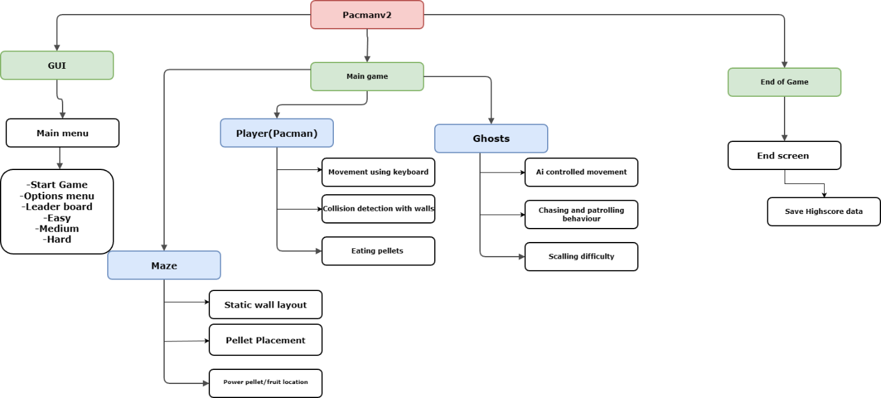
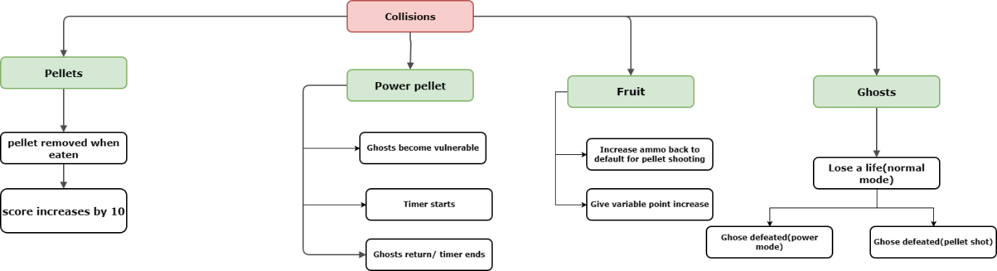
During the development of this project, I will be implementing RAD (Rapid Application Development), which is a type of agile methodology, instead of using another type of methodology such as waterfall. This is because when using a RAD methodology to create the solution prototypes can be created throughout development, so the stakeholders can then give feedback. This is extremely important because it means the stakeholders are allowing for any changes to be made during development, so, the product is to the liking of the stakeholders. However, if the waterfall cycle was used the stakeholders are only included in the development cycle when the user gives the requirements and when they test the product. The disadvantage of using the waterfall cycle is when the stakeholders are testing the product it may not be what the user wanted.

By implementing the use of a top-down modular design, this allows me to identify what I need to do before developing the program, because I can break down each part of the problem into more depth. This allows me to use the computational thinking skill “Thinking Ahead” to determine inputs and outputs that are needed for the game to function properly. Another computational thinking skill that can also be implemented here is “Thinking Logically”, because I will be able to work out what decisions need to be made and where they need to be made. This will give my coded solution structure so the problem can be solved more efficiently. I have broken down the game into 3 main problems and will expand on each of them as collisions is a large part of my game, I also implemented a top-down modular design to showcase what collisions are possible within the game. Each solution to the sub programs will be used to create the end game.

Graphical User Interface:
This will determine what is displayed to the user depending on which pathway they followed, in the user interface.
The first thing displayed is the Main Menu, where there will be buttons with associated key binds, which will lead the player to the appropriate screen depending on which path was followed. The buttons on the Main Menu are the: start, control, easy, medium and hard buttons. Each of the buttons will display a different screen. When these screens are displayed, there will be a way for the player to go back to the previous screen, which would be another key bind.

Main Game:
This encompasses the gameplay itself and what needs to be done to make the game playable and enjoyable.
This is where the player plays the game, where all the processes take place. The main processes required by the stakeholders are the behaviour of the player, the act of shooting pellets, the collisions, input from the user while the game is being played and score monitoring.
The behaviour of the Player:
- When the game is first loaded the Player is presented near the bottom middle of the screen.
- The movement of the player is controlled by arrow keys and WASD (if implemented).
- When an orb, special orb or fruit has been collected, it should be removed from the screen.
The behaviour of the Pacman:
- When a key bind is clicked by the player e.g., right arrow, the striker should then move in the right direction and update its animation to right.
- When all the pellets have been collected, it should soundly return to its original location to begin another round.
- If the striker at any point during the game is pocketed by the user, the striker is then returned to its original position on the board, so another turn can be made by the player.
The collisions in the game:
The collision system has many individual components which is why I created a secondary model to show them. The collision system controls how Pac-Man interacts with other game objects, including pellets, power pellets, fruits, and ghosts.
- When Pacman collides with a standard pellet the pellet should be removed from the screen and the player’s score incremented by 10 points
- When Pacman collides with a power pellet, the power pellet should be removed from the screen, and the ghosts enter the vulnerable state
- While ghosts are vulnerable Pacman can eat them which also results in additional points to the player.
- If Pacman collides with a ghost in its normal state, the player should lose a life and restart their position from the centre bottom of the maze
- When Pacman collides with some fruit, the fruit must be removed from the screen and a variable number of points added to the score as well as an increment to pellet ammo
- When Pacman’s pellets collide with a ghost the ghost should enter their death state and make their way back to the centre of the maze
Ghost Behaviour and AI
The ghosts in the game are controlled using artificial intelligence, which determines their movement and reactions to the player.
- Ghosts should move automatically around the maze
- The ghosts should demonstrate different behaviours such as patrolling the maze or actively chasing.
- As the game progresses or difficulty increases, ghost behaviour will scale with increasing speed
- When a power pellet is active ghosts should attempt to avoid Pacman in their vulnerable state
User input during gameplay:
- This was a major section of feedback as to quote req1, to interact with the environment with ease.
- Keyboard input (Arrow keys or WASD) is used for valid movement inputs and must also prevent Pacman from passing through walls.
- The game should have a continuous loop where it checks for valid movements
- A predetermined key bind may be set for the Pacman to shoot pellets in the direction its facing
- P button can be used to pause the game allowing users to retain progress.
End of Game
This only runs when the end condition is met, which is when all the available pellets have been consumed. The game also ends if the player losses all available lives. Upon reaching the end of the game an appropriate end screen should be displayed such as you lose. The end screen should also display the users final score and allow high score data to be saved, if within the time constraints.

Algorithms that will be needed for the game
Flowchart of the menu system that will be implemented into the game

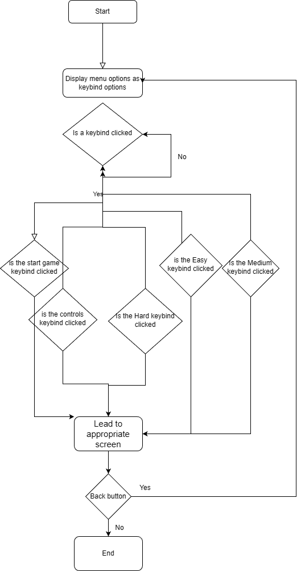

The menu system is the first thing the player will see on the screen once the game is loaded, which is used to navigate through the game. In the main menu the player will see multiple Key binds to attached buttons on the screen; the buttons are start, controls, easy, medium, hard and potentially (leaderboard and quit). If one of the buttons on the screen are clicked the appropriate response is carried out. If the start button is clicked the player displays the game screen, where the player can play the game. If the controls button is clicked, the player is then shown on a screen where the controls are displayed.

Flow chart of the fundamentals of the game.
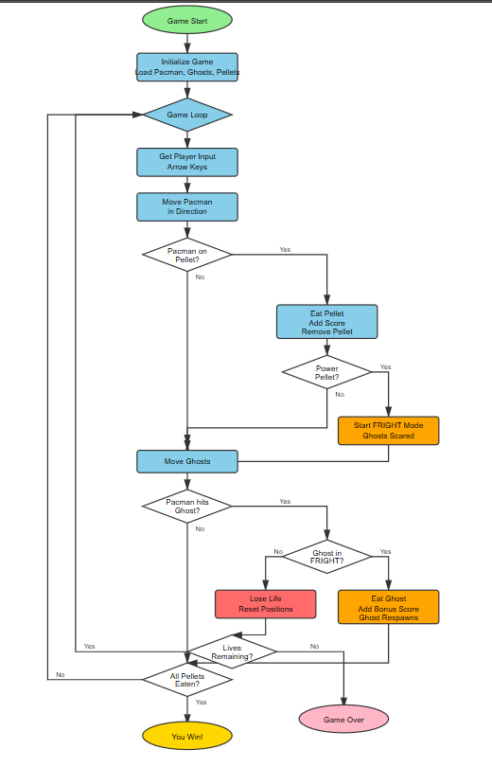

The game begins at Game Start, where all the core elements a of the game are prepared through initialization: Paman, ghosts, walls and pellets are loaded into the maze. The score at lives is set to their default values. Once initialization is over the game enters the main game loop, which runs until the player loses. Within the loop the first step is to get player input. The game listens for the player pressing the arrow keys, which determines the direction of Pacman will move and allocate its related animations. Also, within the constant loop Pacman is continuously checking whether it is on a pellet, which would mean remove the pellet from the screen and increment the score. The game would have a separate condition whether the player is on a power pellet. If the condition is met; fright mode is activated which makes the ghosts vulnerable and avoid Pacman. The game then within the same constant loop checks ghost movements, where each ghost updates its position based on its movement logic and current mode (normal or frightened). After the ghosts have begun to move the game loop checks whether Pacman has collided with a ghost in which case the player loses a life and the game restarts from the original positions of the ghosts a player(s). After a life is lost the game checks whether the player has any remaining lives. If there are no remaining lives the game ends and displays the Game Over screen. At the end of each loop the game checks whether all pellets have been eaten, if so, the player wins and resets positions of ghosts and player whilst the maze is updated, for different routes. The loop continues until the player successfully eats all the pellet and a new level started or loses all lives and the game ends.
Flow Chart of the leaderboard screen

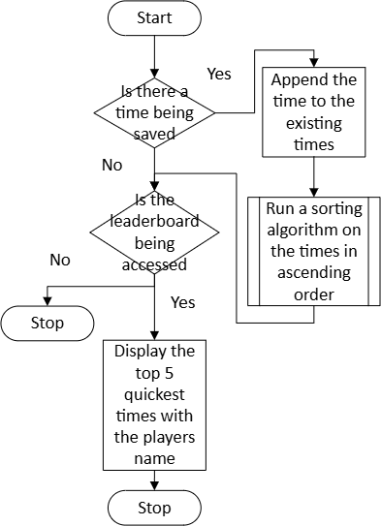

This algorithm is used to display the top 5 times to the user if the leaderboard is being accessed. The first process that needs to be ran is to check if there is a time being saved by the user. If there is, the time is appended by the user to the already existing times, after this a sorting algorithm is run on the times, so the times can be sorted in ascending order. After this the steps that need to be taken are the same even if there isn’t a time that needs to be saved. The first check is to see if the leaderboard is being accessed, if it is the top 5 quickest times are then displayed to the user, then the algorithm stops. If the leaderboard isn’t being accessed, then the algorithm stops. For this algorithm to work, another sub process needs to be written which is the sorting algorithm. The sorting algorithms I’m considering using is the bubble sort or the merge sort algorithm. However, since the amount of data will be relatively small, bubble sort is more efficient in terms memory because all the swaps are made in the original list, whereas if the merge sort is used more memory is required the list is split into individual lists.

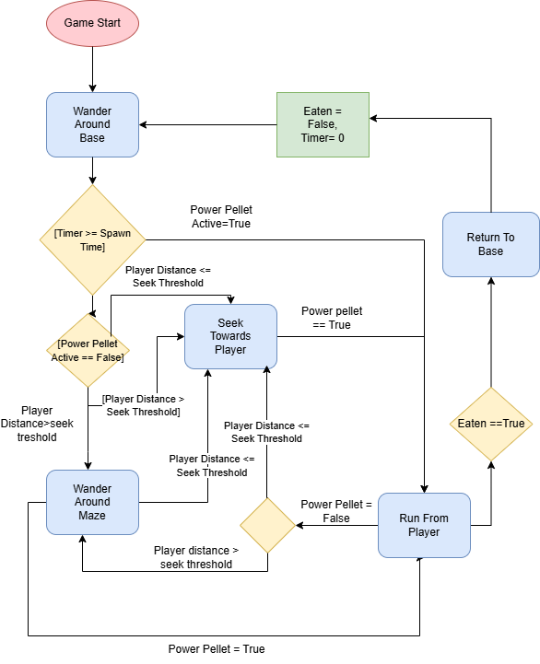
Flow Diagram of Ghost movements
This algorithm is used to control the behaviour ghosts within the game. The purpose of the algorithm is to determine how the ghost moves around the maze, how it reacts to player positions and how it behaves when the player collects a power pellet. The algorithm starts with the ghost’s initialization. At this point the ghost starts in its base area and begins to wander around the base. Variables set are eaten to false and timer set to 0, also ensuring the ghost begins in normal state. Whilst the ghost is in the base a timer is incremented to determine whether spawn time has been reached. Once the timer exceeds the spawn time, the ghost Is allowed to leave the base and enter the maze. After leaving the base, the algorithm checks whether a power pellet is active. If no power pellet is active the ghost, then checks the distance between itself and the player. If the player is within the defined “seek threshold” the ghost switches to a seek behaviour and begins to move towards the player. If the player is outside of this range the ghost instead wanders around the maze. If a power pellet becomes active at any point the ghost immediately changes behaviour to run from the player. The running away behaviour is true if the power pellet is active. Furthermore, the ghost enters a vulnerable state and can be eaten for extra points. If the ghost is eaten the eaten variable is set to True and the ghosts stop interacting with the player instead returns to base. Where it rests its state by setting eaten back to false and resetting the timer to zero. The algorithm then loops and the game continues. The algorithm continuously runs throughout the game loop, allowing the ghost to dynamically switch between wandering, chasing, fleeing and respawning behaviours depending on the player’s location and the current game state.

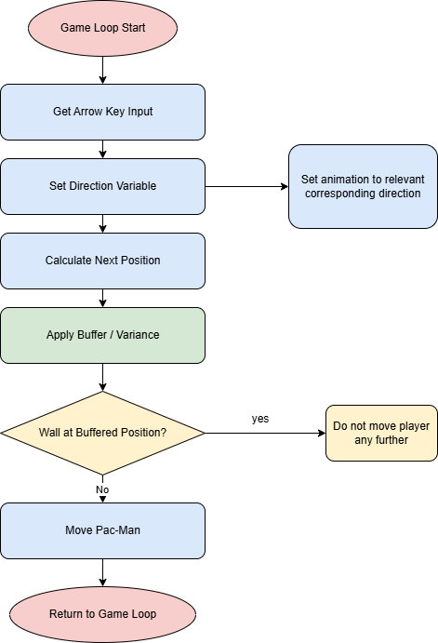
Player input Flow Diagram

This algorithm is used to control the movement of the Pacman during gameplay. The purpose of this algorithm is to ensure Pacman correctly responds to player input and prevents it from going through walls. Also centre the animation within the walls instead of overlapping the hitbox over them which is why there is a buffer or variance variable to account for this. Once an arrow key is detected the algorithm updates the direction variable for the Pacman which holds the current vector position of the Pacman. This allows Pacman to retain direction and movement in specified direction. The buffer slightly offsets the calculated position to ensure that Pacman does not visually overlap with walls. After the buffer is applied the algorithm checks whether a wall is in the requested position, if there is the game prevents Pacman from moving forward. This prevents Pacman from moving into walls and allowing accurate collisions. If no wall is detected at the buffered position the algorithm allows Pacman to move to the new position and updates the characters position vector. This algorithm is placed in the main game loop to allow Pacman to move, while respecting wall boundaries and player input.

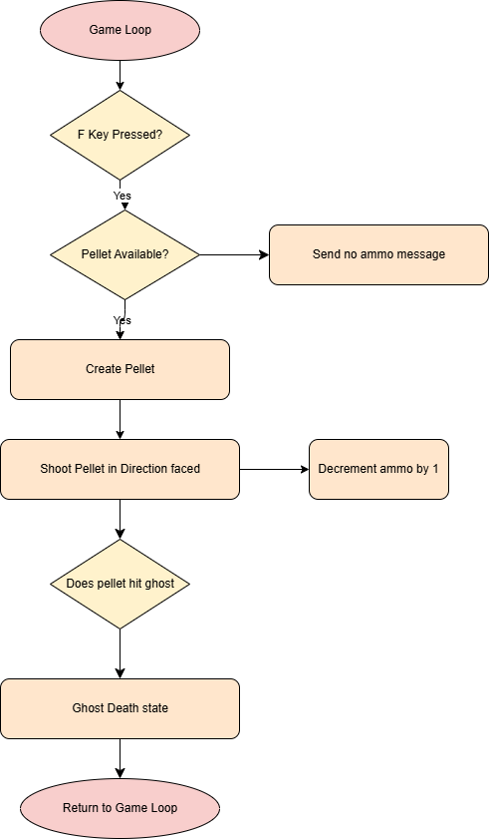
Pellet shooting algorithm

This algorithm is used to control the pellet shooting mechanism for Pacman during gameplay. The purpose of this algorithm is to add unique features to the game. It ensures that pellets are only fired when there are available ammo and the effects of when the pellets have collision with ghosts. If the F key or another key that can be assigned is pressed the algorithm checks whether there are available pellets. This condition limits the number of pellets available, stopping players from abusing the mechanic. If no pellet is available a message will be sent to the player stating no ammo is available. If there is an available pellet; the creation of the pellet will be at Pacman current location and shoots in the direction Pacman faces, then the variable ammo will be decremented. If the pellet is hitting the ghost’s hitbox it sends the ghosts to death state. The algorithm is placed within the game loop which means these requirements are checked every loop cycle.
WRITE PSEUDOCODE FOR BUBBLE SORT

Procedure bubbleSort (array, M)
array - list of elements to be sorted
M - size of the input array
begin
for i = 0 to M-1 do
for j = 0 to M-1-i do
if array[j] > array[j+1] then
swap array[j] and array[j+1]
end if
end for
end procedure
This is the pseudocode that will be used when creating the bubble sort which I’ll use when creating the leaderboard. This is because to display the top 5 times, I’m going to have to use a sorting algorithm to output the times in ascending order. The sorting algorithm I’m going to use is the bubble sorting algorithm, because it requires less memory when compared to merge sort. This is because in merge sort, the total list is recursively split until each element becomes its own list, which increases the memory requirement. However, with bubble sort the values in the list are only being swapped around if necessary.

Key variables and Data structures
Method | Name |  | Data Type | Description |  |  |  |  | Justification
Leaderboard
Game State | Leaderboard |  | N/A | This screen in  the game is  used to display  the top 5  quickest times  and the names  of the players  who got the  quickest times. |  |  |  |  | This is where all  the code that’s  necessary for the  leaderboard will  go.
Procedure | addNewTime |  | integer | This is so the  new time can be  added to the  leaderboard  once the game’s  finished. |  |  |  |  | This will give the  game a  competitive  aspect because it will motivate the  players to improve their skill at the game so they retain game attention
Procedure | bubbleSort |  | N/A | This is the sorting algorithm  which’s used to sort the times in ascending order so it can then be displayed in  ascending  order. |  |  |  |  | This is so the time can be outputted onto the  leaderboard in  ascending order, so the quickest time is at the very top of the  leaderboard.
Text file | Times_file |  | .txt | This is so the times and the names of the players can be stored. |  |  |  |  | This is so the times and the names of the players can be saved, which means they aren’t deleted when the program stops  running.
Menu
Procedure | Menu |  | N/A | At this point in the game the player can pick any of the options that are available on the  screen. |  |  |  |  | This is where all the code necessary for the menu will be.
Procedure | Options |  | N/A | This screen  displays the player with multiple options they can select from |  |  |  |  | This is where all the necessary code for the options screen will be.
Function | enterName |  | string | In this screen the user enters their name so the name can be outputted onto the screen and so it can be saved if it needs to be outputted onto the  leaderboard. |  |  |  |  | This is where all the code is needed so the player can be output and stored is written.
Procedure | Leaderboard |  | N/A | In this screen the top 5 times are displayed onto the screen as well as this the names of the players are  also displayed. |  |  |  |  | This is where all the code for the  leaderboard is written.
Playing
Game state | Playing |  | N/A | At this point the game is being played by  the player. |  |  |  |  | All the code necessary for the game is stored  here.
Variable | Mode |  | String | This variable stores the current state of a ghost using a finite state machine (FSM). values include "scatter" and "chase". |  |  |  |  | ghost’s behaviour, switching between chasing Pac-Man and scattering to corners, creating dynamic difficulty
Variable | Score |  | Integer | This variable is used to store the player’s current score. It starts at 0 and increases when the player collects pellets during the game. |  |  |  |  | The score gives the player feedback on their performance and a clear performance metric to compare runs.
Variable | Power_counter |  | Integer | This variable keeps track of how long Pac-Man’s power-up is active. |  |  |  |  | The counter controls the duration of the power-up allowing ghosts to switch between frightened and normal mode.
Variable | Grid |  | Numpy Array | This variable stores the layout of the maze as a 2D array. Cells with a value of 1 represent walls, and 0 represents open paths. |  |  |  |  | The grid allows the game user and ghost to realise collisions, movement and pathfinding.
Variable | Projectiles |  | list | This variable stores all active projectiles fired by ranged ghosts. Each projectile is updated every frame and removed when it goes offscreen. |  |  |  |  | Tracking projectiles allows the game to manage enemy attacks and collisions accurately, making the game more difficult as requested in Req4
Variable | Time_elapsed |  | Float | This variable stores the amount of time that has passed since the game started or since a specific event. It is used to scale the game’s difficulty over time. |  |  |  |  | Tracking elapsed time allows the game to adjust ghost behaviour and challenge dynamically
Variable | lives |  | integer | This variable stores the number of lives Pacman has remaining defaulting at 3 |  |  |  |  | Tracking lives provides the player a clear limit, creating a dynamic atmosphere which requires the users to try retaining their lives.
Variable | Fire_cooldown(p/g) |  | integer | This variable stores the cooldown time between pellet attacks for either the ghost or player(s) |  |  |  |  | The cooldown prevents the player from shooting continuously removing enjoyment from the game.
Variable | Total_pellets |  | integer | This variable stores the current remaining ammo for the player, when I runs out the player is no longer able to shoot pellets |  |  |  |  | Creates a bonus ability to Pacman’s original game, manages a limited amount of ammo to not be exploited.
Game Settings
Variable | Dt(deltatime) |  | Float | This variable stores the amount of time that has passed since the previous frame. |  |  |  |  | Using delta time ensures that movement and animations occur at a consistent speed on different computers.
Variable | FPS |  | integer | used to store the maximum number of frames per second the game will run at. |  |  |  |  | Limiting the frame rate ensures the game runs smoothly and consistently on different computers.
procedure | paused |  | boolean | This procedure stops the game at the current frame and retains all the positions until un paused |  |  |  |  | Allows player to leave the game and not lose progress.
Display Settings
Variable | SCREEN_WIDTH |  | Integer | This variable is used to store the width of the game window |  |  |  |  | Using a fixed screen width ensures the game displays correctly and its relevant aspect ratios.
Variable | Mouth_frame |  | integer | This variable store the current animation frame for Pacman’s mouth it cycles through numbered frames of different stages of opened and closed |  |  |  |  | Using an animation index allows Pacman to have smooth and visually appealing movement.
Maze Generation
Variable | Visited |  | Numpy array | These variable tracks which cells have been visited during maze generation |  |  |  |  | It prevents the maze generation algorithm from revisiting cells, ensuring a valid, loop-free maze.
Pathfinding
variable | Open_heap |  | List[tuple] | This variable stores the open node the a* algorithm as a priority queue each tuple contains the nodes f score, g score and position |  |  |  |  | The priority queue allows the algorithm to efficiently select the next node to explore, ensuring optimal paths for ghosts. Crucial for ghosts pathfinding
variable | Came_from |  | Dict[tuple, tuple] | The variable maps each node to its parent node in the a* algorithm, used to reconstruct the path from the start to the target node once the algorithm finishes |  |  |  |  | Tracking the parent of each node to build the shortest path efficiently. Ensures intelligent ghosts

Classes (Including key methods)
Class Name: Entity
Key Methods | Description | Justification | Dependencies | Attributes/variables
Update(dt: float, maze: Maze) | Moves the entity based on its velocity, direction, and checks that it remains within maze boundaries | Centralized motion logic so neither ghost or players can pass through walls | Maze(for boundary checks)  Vector2(for position and direction)  Dt(delta time for frame independent motion) | Pos, speed, direction, radius
Render(screen: Surface) | Draws the entity on the game screen at a specified position | Provides a single point for rendering so all sub classes can be drawn consistently without repeating code | Surface(from PyGame) | Pos, visible
Collide(other: Entity) | Checks whether this entity overlaps with another using circular collision detection | Allows collision detection to be shared across all entities making interactions consistent | Vector2 (for position calculations), radius | Pos, radius
Get_bounds | Returns an axis aligned bounding box(AABB) rectangle for collisions | Optimizes collision detection reducing computational effort | Vectror2 - position | Pos, radius

Entity is an abstract base class for all dynamic objects in the game. It provides shared motion, collision and rendering functionality. Which allows subclasses like Pacman and ghosts to inherit common behavior. This reduces code duplication and modularity and maintainability.
Class Name: Pacman
Key Methods | Description | Justification | Dependencies | Attributes/variables
Set_direction(dir: Vector2) | Sets the movement direction of Pacman if the next position is not a wall and triggers the relevant animations | Centralises input handling and ensures Pacman cannot move through walls | Maze (for boundary checks)  Vector2(for position and direction) | Pos, speed, direction, mouth_frame
Eat_pellet(p: Pellet) | Increases the players score by the pellet points if a power pellet is sets power counter to the default value | Handles gameplay progression scoring and power up mechanics in one place | Pellet, score,  Power_counter | Score, power_counter
Die() | Decreases Pacman’s lives when colliding with a ghost if lives remain resets position | Centralises life loss | Entity(for position), Maze (for bounds), lives | Lives, pos,
Animate() | Updates the mouth_frame variable for Pacman’s opening and closing mouth animation | Provides smooth visuals | Speed, mouth_frame, images | Pmoth_frame, speed, images

The class Pacman extends Entity and acts as the main player controller. It encapsulates all states related to scoring, power-ups, lives, and movement animation. Allowing for modular use of Pacman deployment could be useful for creating a second Pacman for 2 player modes.

Class Name: Ghost

Key Methods | Description | Justification | Dependencies | Attributes/variables
get_target(pac: PacMan) | Determines the ghost’s target position based on algorithms. Abstract in Ghost class and overridden in subclasses. | Allows each ghost type to have unique chasing behaviour while keeping a shared interface. | PacMan (for player position), Vector2 | target, mode, ability_type
switch_mode(new: str) | Changes the ghost’s current mode (e.g., "scatter", "chase", "frighten") and adjusts its target accordingly (home position for scatter, etc.). | Centralises FSM logic(finite state machine) for mode switching | Vector2 | Mode, target, home
ability_update(dt) | Executes the ghost’s special ability such as shoot pellets | encapsulates special abilities in one method, allowing different ghost types to potentially have different powers | Cooldown, vector2 | Ability_type, cooldown, target
reverse_on_eat() | Reverses the ghosts direction if eaten while in frightened mode | Shows how the ghost responds when eaten | Vector2 for direction calculations | Direction, mode

The ghost class extends to the entity class and serves as a base for all objects as in ghosts to be organized in a centralized manner. It provides FSM based mode management, targeting and abilities, also allowing subclasses to implement behaviors such as chasing or scattering as visually demonstrated by the above flow diagram.

Class Name: Maze
Key Methods | Description | Justification | Dependencies | Attributes/variables
generate(seed=None) | Generates the maze layout using an iterative depth-first search (DFS) algorithm to carve paths through the grid | Procedural generation ensures each game has a valid and interesting maze layout. Using DFS guarantees connectivity while avoiding loops. | Random(for seed and random choices), np.ndarray | grid, start_pos
build_graph() | Converts the maze grid into a graph by creating nodes for each open cell and connecting adjacent path cells. | A graph representation allows efficient pathfinding for ghosts, separating navigation logic from the raw grid data | Node | Nodes, grid
is_valid_pos(pos) | Checks whether a given position is inside the maze and not a wall by querying the grid. | Important for wall checking logic. | Vector2, np.ndarray | grid
get_neighbors(pos) | Returns all valid neighbouring positions in the four cardinal directions. | provides a reusable method for movement validation and pathfinding algorithms, reducing repeated logic. | Vector2 | grid

Maze represents the procedural game environment and acts as the central data structure for movement and navigation queries. It combines a NumPy-based grid for fast wall checks with a graph representation for efficient pathfinding.
Class: Orbs
Key Methods | Description | Justification | Dependencies | Attributes/variables
get_directions() | Returns a list of all valid connected positions from this node. | Allows pathfinding algorithms to easily retrieve possible movement options from a node, | Vector2 | connections
add_connection(dir: str, target: Vector2) | Adds a connection from this node to another node in the specified direction. | Enables the maze graph to be built dynamically by defining adjacency between nodes. | Vector2 | connections

Node represents a vertex in the maze navigation graph used by ghost ai. Each node stores its position and connections to neighboring nodes. This setup allows ai to quickly determine where it can move next, allowing for efficient pathfinding.

Class: Orb
Key Methods | Description | Justification | Dependencies | Attributes/variables
render() | Draws the orbs as a small circle on the screen. | Provides a simple and intuitive visual representation of pellets | Pygame.draw, Surface | Pos, visible
on_eat() | Marks the pellet as no longer visible when eaten | Allows pellets to be removed from the game efficiently after collection, preventing repeat scoring. | Entity | visible

The pellet class also extends the entity class representing the many collectable orbs within the maze. Pellets can be managed in arrays supporting modular coding requirements.

Class: GameController
Key Methods | Description | Justification | Dependencies | Attributes/variables
Init() | Initializes Pygame, sets up the display, and loads necessary resources like the sprite sheet. | Centralises all game initialization logic, ensuring resources are ready | Pygame | Screen, clock, entities, maze, orb_group, score, time_start
handle_events() | Combines input events, such as key presses. | Centralises input handling, keeping the main loop clean; crucial for manageable code | Pygame | Paused, keypress
update(dt) | Updates all entities, checks collisions, and scales difficulty. | Encapsulates all dynamic game logic in a single method | Entity(for update),  Maze(for bounds), Orbgroup (for orbs),time_start(for difficulty scaling) | Entities, maze, orb_group, score, time_start
render() | This render method clears the screen, draws the maze, entities and HUD elements | Centralising rendering logics | Pygame.surface, Entity, Maze, Pellet_group | screen, entities, maze, pellet_group, score
run() | Main game loop that continues while the player has lives remaining. Calls handle_events(), update(), and render() each iteration. | Manages all subsystems in a organised way reduces complexities within the main game loop. | All other class systems (e.g., Entities, Maze, Pellets, Input, Rendering) | entities, maze, pellet_group, score, time_start

The game controller class acts as the core management of the game, managing the main game loop, input handling updates and relevant rendering. It ties together all sub programs into a single maintainable class. This allows each module to be worked on separately and combined at this stage.

Class: Vector2
Key Methods | Description | Justification | Dependencies | Attributes/variables
__init__(x=0, y=0) | Initializes a 2D vector with x and y components. | Provides a simple, custom vector class to support 2D game calculations | None | X,Y
add(self, other) | Returns a new vector equal to the sum of this vector and another vector | Allows for movement of game entities | Math.sqrt | X,Y
magnitude() | Returns the length of the vector calculated as √(x² + y²). | Useful for movement speed, distance checks, and physics calculations | math.sqrt | X,Y
normalize() | Returns a unit vector in the same direction. | Allows consistent direction handling for movement and AI | Math.sqrt | X,Y
distance_to(other) | returns the distance between this vector and another vector. | provides an easy and readable way to calculate distances for collision | Math.sqrt, other | X,Y

Vector2 is a 2d vector class for handling positions, directions and distances in the game. It simplifies vector math operations with clear methods for addition, magnitude, normalization and magnitude calculations.

Class: AStarPathFinder
Key Methods | Description | Justification | Dependencies | Attributes/variables
find_path(start, goal, maze) | Calculates the shortest path from a start to a goal position using the A* algorithm with a priority queue. | Allows for efficient pathfinding for ghost AI. | Heapq,Maze | None
heuristic(start, goal) | Returns the shortest distance between two nodes used as heuristics for a* algortithm | Guides the A* search efficiently towards the goal while ensuring optimal path selection. | None | None

AStarPathFinder implements modular pathfinding for Pacman’s ghosts. Using the A* algorithm with a heap-based priority list allows ghosts to find optimal paths at greatest efficiency.

Describe the Solution
Usability
Almost every single videogame has some sort of menu system which the player can use to explore and play the game. Most games have three typical interfaces: a screen that is displayed when the game is loaded, a screen where the game is displayed to the user and a screen that is displayed to the player after the game ends.
An example of a user interface that can be implemented into my game is the use of a stopwatch; this is so the player can track how long they have been playing a level so they can then determine what to do next, which is classified as HUD (head-up display). This feature has been discussed with my stakeholders, and they have all agreed that this feature is extremely useful to their experience playing the game. However, one piece of feedback on the
implementation of this feature is to make sure that it doesn’t take up a lot of space on the screen, which means the player can focus on the game.

Image | Reference | Description
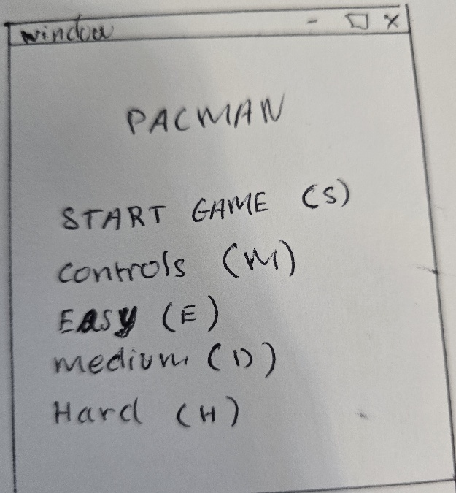 | D1 | This is the main design of the main menu, which the player will first interact when they play the game. The main feature of this is to show game modes options and controls. As well as this there are allocated key binds that the player will use to navigate through the menu. The buttons will have start game, controls and game mode options. Each of these key binds will lead to a different screen.
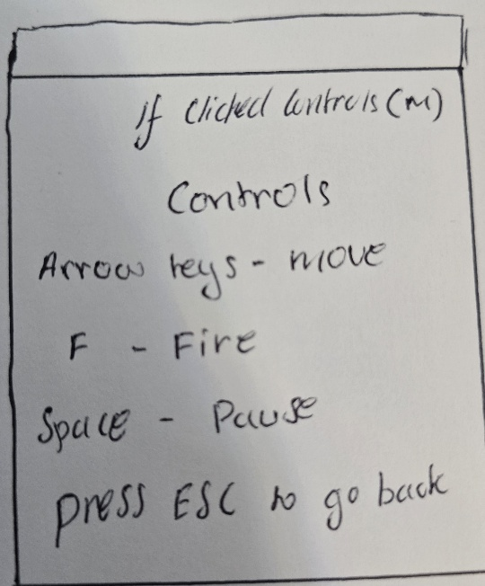 | D2 | when the control key bind is clicked the information is going to be presented in the following fashion, with some lines of text. The heading says what the screen is. All display information will be represented in a similar fashion, which is why I’ve drawn the image  like this.
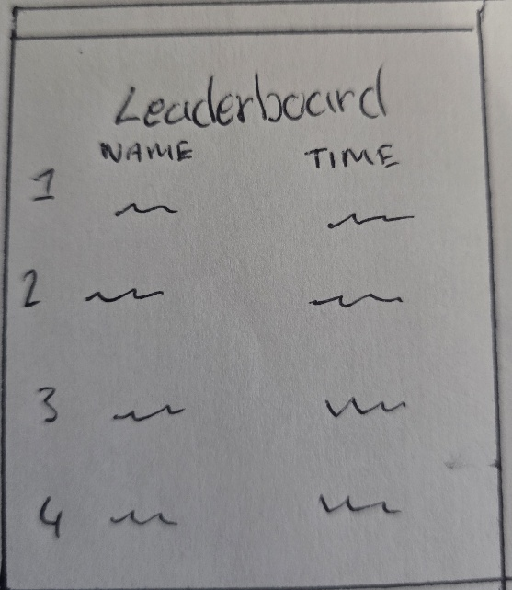 | D3 | This is the screen shown to the player after they beat the game. It’s a leaderboard screen, which shows the name of the player and their corresponding time to beat the level. One of the design features, that I would like to implement in the leaderboard function is that the first, second and third numbers on the side have the colours gold, silver and  bronze respectively. This is to signify the people with the quickest time, second  quickest time and third quickest  time.
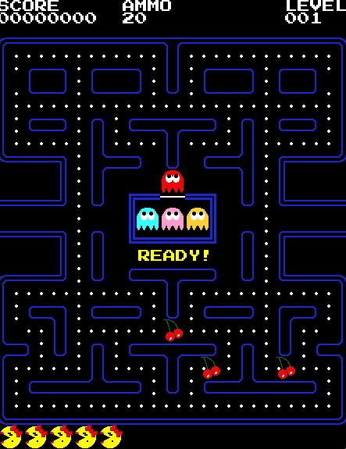 | D4 | This screen design is what the player will be shown when they click the play button on the main menu in D1. This design is not final, because tweaks might be made for example the timer  This is a graphic representation of the final game in theory. It displays cherries on the maze that represent ammo collection. Pellets across the maze representing point collection, lives ghosts, level, score and ammo are all displayed in the corresponding image.

Class Diagram

Class name: Menu
Attributes: Text: String, Position: Tuple
Methods: def Display(self):
Def keybinds(self):

I am using a class to make the menu screen that will need to be added in my game, because PyGame doesn’t have a built-in function for buttons which means I have to use keybinds to replace them. The attributes for the button class are “Text” and “Position”. These are used to create the writing so it can be displayed onto the screen. The attribute “Text” is the text that is added to the screen, e.g. the text could be “Start Game”, which is then added to the screen. The attribute “Position” is a tuple which stores the position of where the text is added to the screen, e.g. the position that’s passed in could be (200,100) which means the centre of the button will have coordinates of (200,100). The methods for the button class are “Display” and “key binds”. The method “Display” adds the text to the screen, so the player can see it can interact with it, it takes in the “Text” and “Position” as parameters, so the text has the correct text and is in the correct position. The method “key binds” is used to check if the certain key bind is clicked and returns the appropriate Boolean value to the main code, True if key was clicked and False if it wasn’t clicked.

My Pacman game is developed using oop – object-oriented programming – approach because the game contains multiple entities with unique behaviours. The core game entities such as Pacman, ghosts, pellets and the maze are represented as separate classes as mentioned above allowing each to be modular and manage their own data and logical operations. Inheritance is also used to reduce code duplication, for example by using a shared entity base class for all moving objects. Furthermore, user input is predefined to controls such as arrow keys and menu navigation key binds, which reduces the risk of invalid input and removes the necessity of a mouse. Validation within my game is important and is used when checking movement against the maze grid, preventing Pacman or ghosts from moving through wall or exiting the playable area. Other validation also includes entities overlapping such as Pacman and the ghost where this effects lives and restarts the current game cycle.
Describe the approach to testing
These are some of the key milestones that will be referenced to duting the development of the game, and these key milestones are based on the success criteria outlined by the stakeholders.
Key milestones:
- Main Menu / Start Screen
- Random Maze generation
- Ghost Behaviour and AI
- Scalable difficulties
- Game End conditions
- Leaderboard
- Two player modes
These are the individual milestones that I’ve broken down into multiple smaller requirements to make it easier to make the coded solution.
Milestone 1: Main Menu/ Start Screen
Test Number | What is being tested and inputs | Expected outcome |  |  | Justification
1 | The main menu is displayed to the users when the game is first loaded | A start screen is shown with clearly labelled |  |  | To ensure that the player can see all the available options, and how to access them
2 | The menu buttons respond to keyboard input | Selecting a menu option transitions the player to the correct window |  |  | To verify that the user input is correctly detected and handled
3 | The game can be closed using an exit option | The game window closes when the exit option is clicked or back when esc is clicked |  |  | To confirm that the user can safely exit the game.
4 | The game starts when the start game option is selected | The gameplay screen loads and Pacman appear in the maze |  |  | Ensures that the game is accessible through the main menu

Milestone 2: Random Maze Generation
Test Number | What is being tested and inputs | Expected outcome |  |  | Justification
1 | The maze is generated when the game starts | A complete maze is displayed before the game play begins |  |  | The player must always have a playable maze before the game begins
2 | The maze layout changes when ascending levels/ game resets | A different maze layout is generated on each new game |  |  | To confirm that the maze generation is random
3 | All paths in the maze are reachable | There are no isolated areas, and Pacman can access all pellets |  |  | Ensuring maze validity and the game is always winnable
4 | Wall prevent movement through invalid areas | Pacman and ghosts should not be able to move through wall tiles |  |  | Validate collision and boundary checking
5 | The maze size remains consistent across generations | The maze always fits within the game window |  |  | To ensure that the maze does not break the game display

Milestone 3: Ghost Behaviour and AI
Test Number | What is being tested and inputs | Expected outcome |  |  | Justification
1 | Ghosts move automatically when the game begins | Ghosts begin to move as soon as spacebar is clicked and game is started not when player movement is confirmed |  |  | Confirms that ghost movement is controlled by AI logic rather than user input
2 | Ghosts change their behaviour based on current mode | Ghosts switch between modes such as chase and scatter |  |  | To ensure the finite state machine controlling ghost behaviour works as intended
3 | Ghosts correctly target Pacman’s position | By use of pathfinding algorithms, the ghosts should chase Pacman when in chase mode |  |  | To create a dynamic ai ghost environment
4 | Ghosts respond correctly to power pellets | Ghost enters a frightened state and change movement behaviour |  |  | Ensures Pacman’s Power ups affect enemy behaviour correctly
5 | Ghosts collide with Pacman correctly | Pacman loses a life or defeats the ghost depending on the current power state |  |  | Validates collision and correct hitboxes
6 | Pacman is able to shoot pellets in the direction its facing | Pellets should put ghosts straight into death state or the frightened state |  |  | Creates a new feature/ mechanic to the Pacman game

Milestone 4: Random Maze Generation
Test Number | What is being tested and inputs | Expected outcome |  |  | Justification
1 | The game difficulty changes as the level progresses over time | Ghost behaviour becomes more challenging the longer the game runs, with limitations |  |  | To confirm that difficulty increases gradually rather than remaining static
2 | Power Pellets temporarily decrease difficulty | When a power pellet is eaten, ghosts should enter frightened state |  |  | To balance increasing difficulty
3 | Ghosts can shoot pellets | After a certain number of pellets are collected one of the ghosts gains the ability to shoot pellets |  |  | To ensure dynamic gameplay
4
  Difficulty resets when a new game is started.
  Difficulty resets when a new game is started.
  Fairness towards the player

Milestone 5: Game End Conditions
Test Number | What is being tested and inputs | Expected outcome |  |  | Justification
1 | The player picks up all the pellets. | The game is over the next level begins |  |  | Confirms win conditions to progress to the next
2 | Pacman loses all available lives | The game ends with the game over screen and asks the user for name to score on the leaderboard |  |  | Ensures a lose condition
3 | The game stops updating when paused of game end | Player input and entity movement are disabled |  |  | Ensures game is not running when conditions are not met
4 | End of game display
  Displays final score and time
  Give the user feedback on their game performance

Milestone 6: Game End Conditions
Test Number | What is being tested and inputs | Expected outcome |  |  | Justification
1 | The leaderboard option is selectable from the main menu | The screen is displayed in correct order |  |  | Ensure leaderboard can be accessed correctly
2 | A completed game with a score is recorded | The player’s score is saved to the leaderboard |  |  | To confirm that scores are stored correctly

Milestone 7: Two player game mode
Test Number | What is being tested and inputs | Expected outcome |  |  | Justification
1 | Two player mode is selectable from the main menu | Game loads corresponding characters into the game |  |  | Ensure the two-player mode can be accessed correctly
2 | Player 1 movement for example arrow keys | Player 1 moves correctly within the maze |  |  | Verifies player 1 controls work as intended
3 | Player 2 movement for example WASD | Player 2 can move independently |  |  | Ensures correct movement controls
4 | One player loses all lives | That player is eliminated
  Ensures fairness within the game
5 | Both players lose all lives | Game ends and game over displayed with players corresponding scores |  |  | Makes the game more entertaining against a friend instead of alone against the AI.

These are some of the post developments tests that will be ran once the games completed.

Post Development | Testing to be performed post-development | Justification
Bug and Glitch testing | One of the tests that needs to bee ran is collision testing where the ghosts, Pacman, walls pellets shot, orbs are all detected by game entities | This is because player retention is decreased when a game full of bugs is released, because it ruins the playing experience and makes it look like the programmer didn’t put any effort into it.
 | Another test that will be conducted is the analysis of ghost modes making sure they are able to make switch between scatter, chase, frightened, death state etc.. | This is because without these fundamental functions the game may become unplayable.

Post Development | Testing to be performed post-development | Justification
Functional testing | To make sure collisions are correctly registered | This is to check that Pacman and the ghosts have working collision mechanisms in place. It’s also to make sure there are no unrealistic movements such as walking through walls
 | Ai is following Pacman correctly | This is to make sure that the game is functioning correctly and there is a challenge to play against

Post Development | Testing to be performed post-development | Justification
UI (User interface)  functionality | This is to check that the player can navigate through the menu with ease. | This is because glitches in the UI in a game can cause some players to get confused as to how the game works and the controls that are necessary to navigate  through the game.

Developing the Solution
Phase 1:
Development of the Game itself
Iteration 1
In this first iteration I need to create modular sections of code through classes and .py files to manage the creation of the main character Pacman and its animation, movements and positions. This will include my entity Base class, Node and maze navigation system, rendering system and input handling.
Entity class.
Description | Code | Output

